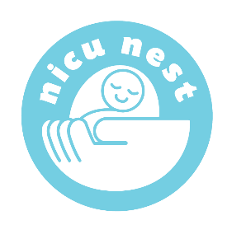
In Collaboration with Riley Hospital for Children

Our NICU Nest Family Support Program supports families in 3 NICUs on campus, as well as our Neonatal Step-Down Unit, CVICU Newborn service,Outpatient Fetal Center Clinic, and Maternal-Fetal Medicine patients on inpatient bedrest. Each family support coordinator job description is different. We also have a former NICU parent who is our program Project Coordinator.

This is snapshot of the services we provide.
Parent support at bedside
Parent and staff education
Healthcare financing assessment and support
Weekly/monthly activities
Holiday celebrations
Care conference support
Memory making/name banners
Weekly milestone photography
Weekly family meals
Participate on Research/QI projects
Provide parent voice of hospital committees
Facilitate NICU Family Advisory Council
Facilitate NICU Reach Out and Read program
Host annual NICU Fun Walk

